All Sunday school classes begin at 9 a.m. in the Sanctuary.
Children’s Sunday School:

How can we know what God is Like? What’s so special about the Bible? What is the Gospel? These are big questions, and by exploring them, kids can engage their natural curiosity and discover the amazing answers that God’s word has for those who seek them. In the Praise Factory kids become detectives, searching for understanding, and in the process finding that God is amazing and worthy of praise! Each of the three levels of The Praise Factory is built to grow with kids and encourage them to take part in learning through Bible verses, stories, and games. It is our hope that through digging for answers in a fun and memorable way, the Praise Factory will send kids home with exciting stories of God’s goodness, and with a desire to return and keep learning!

The Sunday School Classes are:
- Hide ‘N Seek Kids, Ages 3-5(Pre-K). Hands-on activities and repetition are the key in this age group. We want kids to be able to remember the Big Questions and the Bible Stories presented, and to come away excited to return.
- Deep Down Detectives, Grades K-3. Interaction is at the core of the Praise Factory curriculum, and it shines in this age group, where kids can utilize their developing memories and take on fun responsibilities in helping with the lesson and activities. Repetition is still a big part of this age group as well.
- Praise Factory Investigators, Grades 4-7. This age group is introduced to the same Biblical truths in multiple ways through the lessons, seeing how God’s word and God presence in history provides the answers to even the biggest of life’s questions. There is also a greater focus on seeing themselves as part of the church in preparation for continued body life as they grow older.

New Adult SS Electives:
What Did You Expect? Redeeming the Realities of Marriage.
Discover how to develop a marriage of unity, understanding, and love! You’ll never have a perfect marriage, but understanding the truth of who you are, who your spouse is, and what to expect of a marriage Biblically will help you avoid some painful pitfalls. And beyond seeing some of the threats to a healthy marriage, knowing what you ought to expect can help you view marriage not as a contest or a contract, but as something much more amazing, as worship to the Lord. This class is led by Steve MacDonald, beginning in the Sanctuary @ 9:00 a.m.

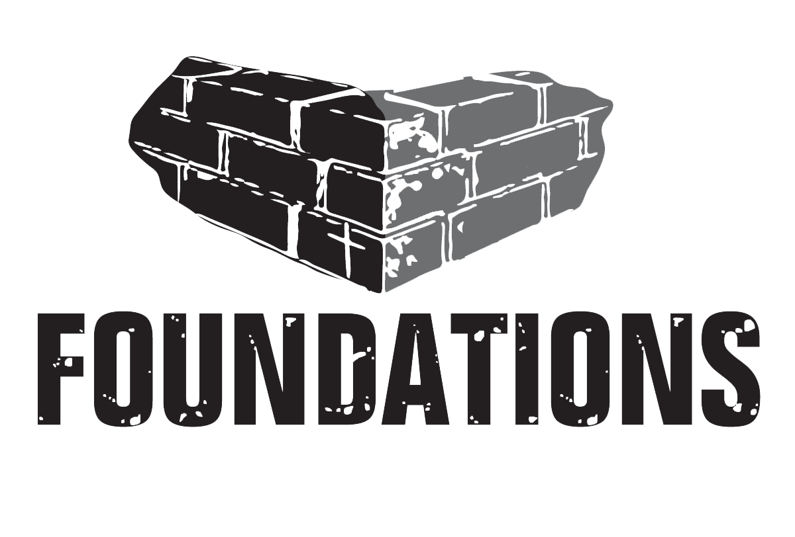
The Beauty of Church. Who is the church for? What is its purpose? Where do you fit in? This core class will explore God’s intentions and instructions for His much-loved Church. Led by Pastor Scott, meeting in the Sanctuary @ 9:00 a.m.
United Men’s Discipleship Group
When? Wednesdays @ 5:30 a.m.
Where? The UBC Prayer Room (upstairs)
What is it? A time for men to gather around the word and grow together. The goal of discipleship groups is to live out Colossians 1:28, “proclaiming, admonishing, and teaching with all wisdom, so that we may present everyone mature in Christ.” This men’s group is currently finishing a study through 1 & 2 Samuel, with 1, 2, and 3 John to follow. For more information contact Steve MacDonald at steve04640@gmail.com.
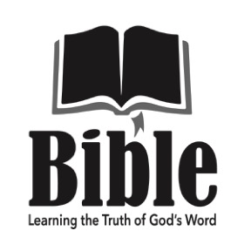
1:1 Bible Reading Group
When? Wednesdays @ 6 p.m. beginning 1/11/23
Where? The UBC Dining Room (downstairs)
What is it? An 8-week Bible study through the book of Ephesians, utilizing the 1-to-1 Bible reading method. This group will be examining God’s word in a way that allows each person to engage actively with what is being presented and discussed. The 1-to-1 reading method is a tool for evangelism, discipling, and family devotions that is driven by God’s word and directed toward each person who uses it. There is a sign-up sheet for this class in the Welcome Center. For more information contact Mike Page at mpage@ubcellsworth.org.
United Women’s Mom’s Group
When? Mondays @ 9: a.m. beginning 1/16
Where? The UBC Nursery
What is it? A discipleship group for stay-at-home moms and mothers with young children. Growing in the Lord takes dedication and hard work and doing it while raising small children is even harder. This group meets in the nursery so that kids can play and connect while moms do the same, gathering to study God’s word and to encourage and exhort one another toward continued growth and strengthening in Christ. You can expect spills, bumps, and diaper changes to interrupt your study, but can also expect honest conversations about life, opportunities to build one another up, and for God’s word to speak. There is a sign-up sheet for this class in the Welcome Center. For more information contact Liz MacDonald at lizlauramac@gmail.com.
United Women’s Bible Study
When? Wednesdays @ 5:30 p.m. beginning 1/18/23
Where? The UBC McEldowney Room (downstairs)
What is it? A time for women to come together and hear from God’s word. As commanded in Matthew 28:18-20 we are seeking to make disciples, and the primary method given for doing this is teaching, with the expected result being obedience to the word of God. This 9-session study will be exploring the book of Romans and seeing just how great the mercy and goodness of God is. There is a sign-up sheet for this class in the Welcome Center. For more information contact Liz Conners at 207-460-9621.
Healing Hearts
When? Wednesdays @ 6 p.m. beginning 1/18/23
Where? The UBC Counseling room (downstairs)
What is it? A 10-week women’s study on the hope and healing there is in Jesus Christ. The truth of God’s word is for broken hearts, and we have all been damaged in some way by sin. This study of scripture shows how, more than putting our hurts behind us, God wants to heal them. To ensure ample opportunity for sharing and connection this study is limited to 5 women. To reserve a spot or for more information, contact Tarnya at ubc@ubcellsworth.org.

